Report: Conservation needs in Iraq Museum, Baghdad

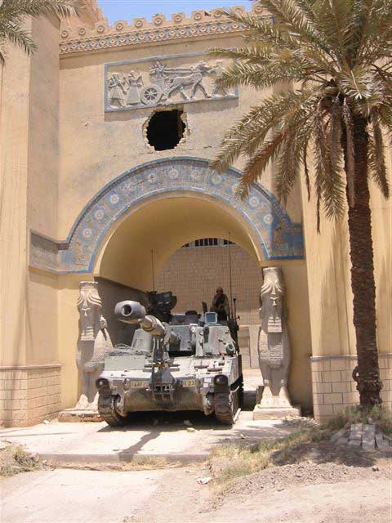

Figure 1. Main entrance gate to Iraq Museum, Baghdad. © B. Christensen, The British Museum.
Executive summary

Our visit confirmed the initial impression of substantial damage to the collections in the Iraq Museum caused by the recent war.

It was predominantly stone, ceramics and ivory objects that had suffered the most as a result of recent events. This is not to say that other groups of objects have not been damaged, but it was our opinion that they were of a lower priority in terms of status or category of damage. Many of the damaged objects will require complex and comprehensive conservation solutions. Others have already been repaired and are ‘back on display’ whilst others may be undergoing work prior to an international team arriving in Baghdad.

The Iraq Museum is currently guarded 24 hours by American troops. There is four tanks within the Museum site; one of which is located under the main entrance porch to the Iraq Museum (fig. 1).

Based on our survey we drew up a conservation plan with suggested timescale (albeit a little optimistic as regards obtaining visas and passports). This was approved by the senior management at the Iraq Museum and seemed to meet all of their requirements. It should also be noted that the conservation plan had been discussed with the senior conservator (Buthaina Musslin Abdul Hussein) who agreed with the proposal.

There is a major lack of infrastructure in the Iraq Museum, not only in terms of laboratory facilities and even of basic chemicals for conservation, but also the lack of reliable power and water supplies. While it is planned that new laboratory facilities will be supplied by the Italian Ministry of Cultural Heritage and Antiquities by the beginning of October, the return of the public utilities to normality is less predictable. The continuing instability of the country is a further factor not to be underestimated. In such a context, uncoordinated aid, while well meaning, may be ineffective or at worst of no benefit.

The conservation plan, appended as a separate document to this report, aims to provide Iraqi conservators with the training they themselves want and to bring together an international team with skills and expertise in the conservation of those types of collections that were found to be most at need. This team will spend three months in the Iraq Museum from October 2003. The timing allows for this training, travel documents permitting, and for the formation of the team, but also for the installation of laboratory facilities and, it is hoped, the re-establishment of utilities and stability necessary for effective and safe working conditions.

Introduction
A team of senior conservators and curators from The British Museum visited Iraq between the 11th June and 26th June. The brief was to assess the damage to the collections, predominantly at the Iraq Museum in Baghdad and to establish and seek agreement to a programme of conservation help that would be coordinated by The British Museum under aegis of UNESCO. The brief was extended to include Mosul Museum and some of the northern archaeological sites such as Nineveh and Nimrud as well as visiting Babylon.

The team was led by Dr. John Curtis (Keeper of Department of Ancient Near East) and included Dominique Collon (Curator in the Department of Ancient Near East), Ken Uprichard (Head of Inorganic Conservation) and Birthe Christensen (Head of Conservation); all from The British Museum.

The team spent initially 5 days in Baghdad working in the Iraq Museum. Access was granted to many of the stores, all display areas and to some of the secure off-site stores. Contact was established with the conservation team, led by Buthaina Musslin Abdul Hussein to assess the damage to the conservation workshops and to obtain information on the help the conservators would like.

Five days were spent on visiting archaeological sites outside Baghdad. On our return from Mosul (near the Syrian border to the north) we had the opportunity to revisit the Iraq Museum and tie up a few loose ends before presenting our proposed conservation plan outlined in detail in a separate document attached to our survey report. We met with respectively the senior staff at the Iraq Museum and Ambassador Cordone, who is heading up the interim Ministry of Culture for the Coalition Provisional Authority (CPA).

The conservation workshops
The conservation workshops are situated on the first floor of the Iraq Museum. There was evidence of recent damage and vandalism, both to the fixed furniture (e.g. air conditioning and extraction units) and to the portable equipment. The chemical store seemed well stocked, although some ‘sell by dates’ were truly exceeded. Some essential solvents and conservation materials have not been available for some years due to the trade sanctions imposed on Iraq and some lesser desirable substitutes from a long-term stability point of view were in stock.

Some of the workshops had small windows placed high on the walls. It was not possible to open these windows for security reasons. In the facsimile room there was evidence of small electric extractors placed in the window openings. Most of these had been removed when the vandalism and looting took place.

Services to the Museum (water and electricity) are erratic. The conservation workshops did still not have any water in June, although other areas in the Museum were slowly being connected. The generators connected to the Museum were not powerful enough to run fume cupboards and air coolers in the workshops, let alone elsewhere in the museum. It is therefore difficult to assess the effectiveness (or indeed the working order) of the fume cupboards. However, the fixed fume cupboards will not adequately deal with the increasingly stringent health and safety regulations.

The Iraqi conservators have a very proactive attitude and they have already started the tidying up process in order to establish their need for equipment and materials. An offer from the Italian Ministry of Culture and Heritage was received in Baghdad during our visit. The proposal was assessed in relation to our findings and the established needs of the Iraqi conservators for developing their skills and competencies. It is anticipated that the Italians will order the necessary equipment and install same by October 2003.

The main and most urgent need in the workshops is the installation of air-conditioners (the average temperature in June is 45°C and rising in July). Another urgent need is the installation and testing of fume extraction (both portable and fixed cupboards).

Conservators (staff)
We were informed that there were 8 conservation staff (seven women and one man) employed by the Iraq Museum. The conservation team is led by Buthaina Musslin Abdul Hussein (fig. 2). She is a trained chemist and has spent 3 months in Mainz (Germany) working on bronzes. The conservation team come from a variety of backgrounds (physics, crafts, arts and archaeology). They would all appear to have been trained on the job. There are different attitudes to conservation within the department. Some are interested in learning and expanding their skills, others are quite content being told what to do and how to do it.

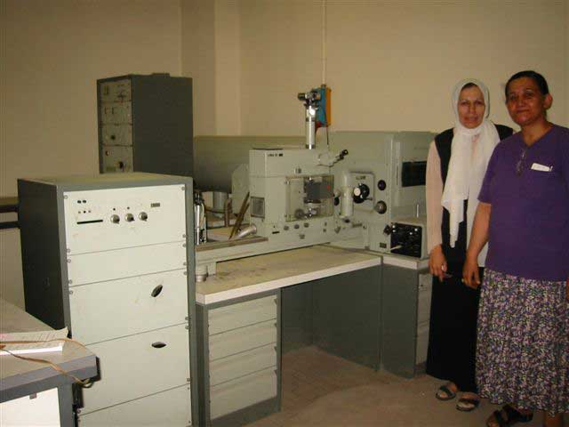

Figure 2. Buthaina Musslin Abdul Hussein and Luma Abduselam Mahmod, Iraq Museum conservators. © B. Christensen, The British Museum.

Buthaina has identified that her team needs training in conservation of bones, metals and glass. However, we felt that the majority of the objects in most need of conservation, following the recent vandalism, were ivory, stone and ceramics.

The conservation literature and recommended practices used were predominantly based on Plenderleith and Werner’s book ‘The Conservation of Antiquities and Works of Art’. Due to various sanctions placed on Iraq over the last 10-15 years there would appear to have been no progress or development in conservation techniques or choice of materials. It could probably be compared to the conservation methods and/or standards of the 1970’s BM.

Mosul Museum employs one conservator, who has over 20 years experience of on-site and museum conservation. We got the impression that there is a good working relationship between Baghdad and Mosul. Combined, this team of nine conservators cover all of Iraq’s conservation needs as pertaining to archaeological material. We were not informed that any paper, book or painting conservator operates in Iraq and it was outside our scope to investigate these areas.

Conservation Library
Some books had been donated by Unesco over the years and some articles are translated into Arabic. Arbeitsblätter (German conservation journal) is read by Buthaina; she is currently the only one who speaks German. It was not apparent that any English conservation journals was taken and/or read. We very much got the impression that Plenderleith’s book was standard reference for conservation techniques.

It is our opinion that the Conservation Library should be expanded to provide a comprehensive reference library for all of Iraq. This can likely be achieved through donations from major institutions and individual conservators, either through donating small sums of money or copies of publications. The co-ordination of this library could comfortably sit with for example United Kingdom Institute of Conservation Archaeological Section with links to the BM to avoid duplication of efforts.

It is also our opinion that some key text books on archaeological conservation should be translated into Arabic and again this could be funded through the conservation community or aids organisation, for example UNESCO. A list of Arabic speaking conservators (for final editing of the translations) should be identified and a list of translators and/or publishing houses prepared to take on this task should be investigated.

Display areas
We had several comprehensive visits to the display areas. There are clear signs that some tidying up has occurred. Fragments have been gathered in groups or boxes to prevent key pieces being lost. Large sculptures that had been pushed over, or laid down for safekeeping, have been erected where there is no structural damage. Many large sculptures have been protected with thick layers of foam and some of the Iraqi museum staff are in the process of removing much of this debris.

Many glass cases, empty of objects at the time, have been smashed and gallery floors are now covered in glass shards (fig. 3). Windows at high level have been broken and the galleries are extremely dusty. During our visit the cleaning of the galleries began to start in earnest. Water had recently been connected albeit the supply is intermittent.

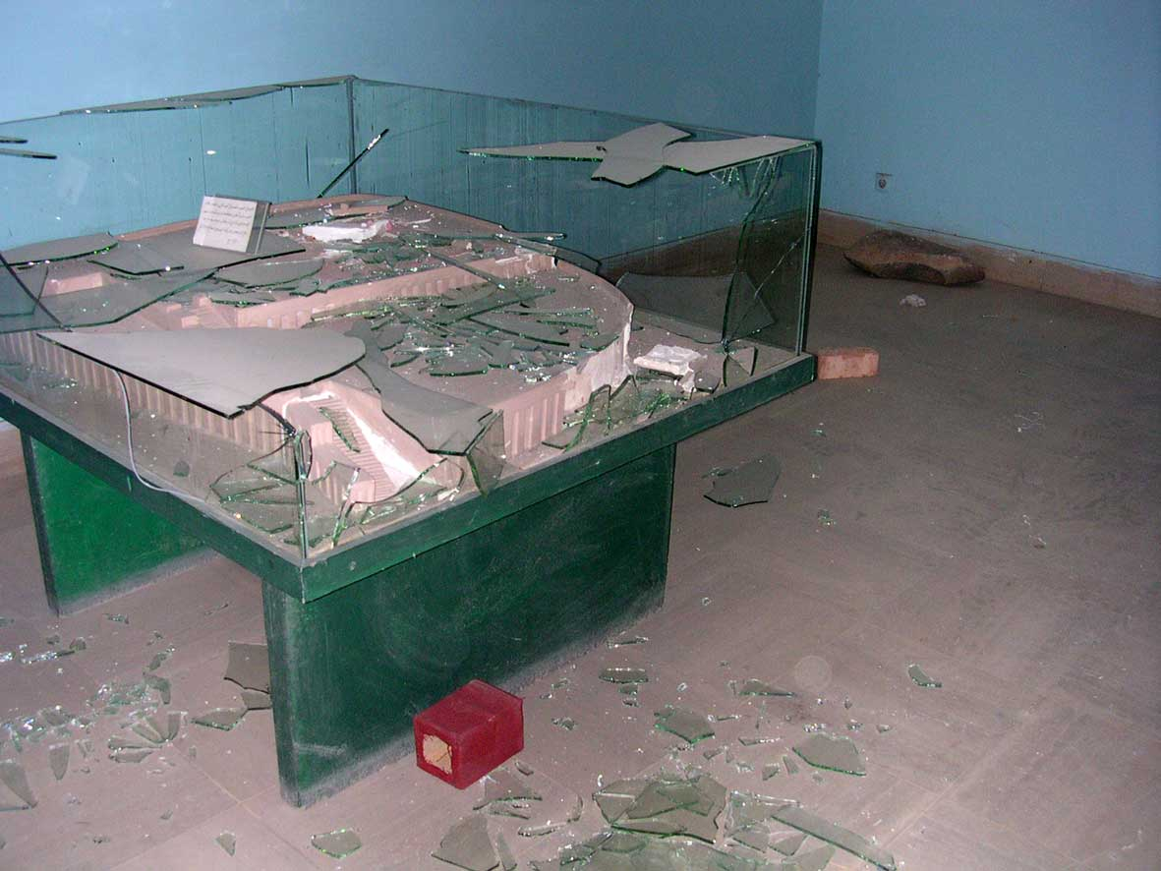

Figure 3. Wanton vandalism in Iraq Museum, Baghdad. © D. Collon, The British Museum.

Damaged objects are slowly being packed away. Fragments are being boxed or otherwise kept together with the larger pieces of the objects. The upper floor in the Museum had not been tidied up prior to our arrival. It was our impression that three groups of objects were at risk and should be packed away as soon as possible:

- The Ubaid display. The six ceramic rosettes are now severely fragmented and to some degree almost pulverised and lay scattered on the floor. It is uncertain exactly how much has survived. We later saw one rosette (slightly damaged) in the returned objects store and it is our impression that all the pieces are present to allow a full restoration of the six rosettes to be carried out.
- The other group of very badly broken objects were three less than life-size marble statues from the Parthian period. These statues were toppled onto the floor. A statue of Poseidon IM73005 is broken into many pieces and some shattering of the marble has occurred. The other two statues are less severely damaged. They have all been restored at some point and the iron dowels will require replacement (fig. 4).

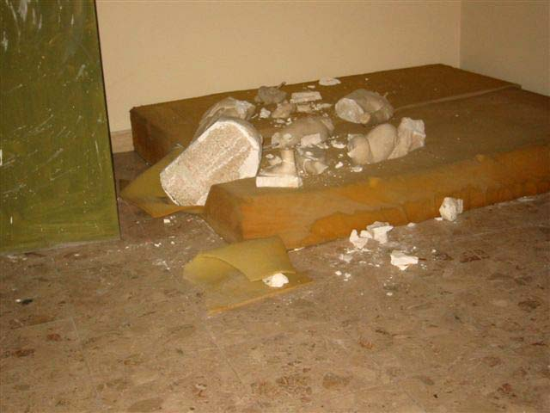

Figure 4. Parthian marble statues, Iraq Museum, Baghdad. © B. Christensen, The British Museum.

- A group of Tell Harmal and Haditha lions (ceramics), all extensively restored with plaster of Paris, were badly damaged. One lion was shattered and second lion had been pushed over. The latter lion had been wrapped in bubble wrap and it was unclear how much damage it had sustained. The head of the third lion (Harmal lion) had been broken away from the body leaving shattered break lines in original fabric. The head is severely damaged.

There were other objects damaged. A detailed condition report exists for all objects in the display area with photographs. This list of objects is high on the priority for conservation and will probably form the basis on which a team of conservators will be selected.

On-site objects stores
We visited several stores, all predominantly housing ceramics. Some tidying up had occurred, although there was still a lot of evidence of wanton vandalism. Objects have been pulled off shelves and were smashed on impact with the floor. It should be noted that the basement store was inspected with torches as the electricity supply to the museum failed that morning. The upper floor stores had some daylight which helped with the inspections.

The stores appeared well organised. The objects were stored on open metal shelves with what appeared to be location codes placed on the end panels. An area for registering objects existed. It was apparent that many objects had been brought into the museum stores for safe keeping. These were stacked on whatever available floor or shelf space. This increases the risk of damage to objects, not necessarily as a result of vandalism, but as a result of over crowding a store in a difficult situation (fig. 5). It is our opinion that visits to the stores should remain limited till further clearing up and some order is reintroduced to the stores.

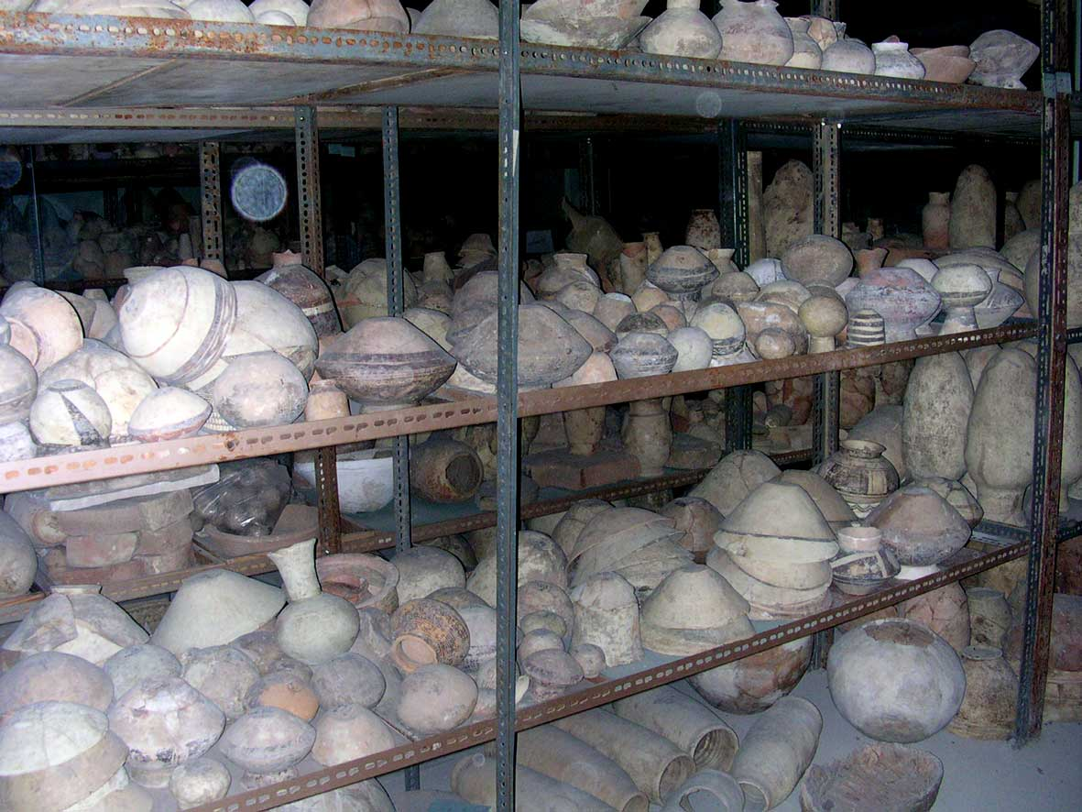

Figure 5. Overcrowding of ceramics on shelves in basement store, Iraq Museum, Baghdad. © D. Collon, The British Museum.

It was very difficult to ascertain the number of looted objects or damage to collections. Only through a systematic shelf by shelf assessment of objects can the true extent of conservation backlog be established. It will be extremely difficult to distinguish between latent damage as a result of overcrowding and direct damage as a result of vandalism. It is however beyond dispute that damage has occurred due to vandalism.

The majority of objects damaged were made of ceramics, stone and ivory. Probably the ivory objects are the most severely damaged and will present a complex conservation challenge (fig. 6). Several boxes of ivory, originally packed in plastic bags, have been emptied onto the floor. In this process many of the ivories have been severely fragmented and some almost pulverised.

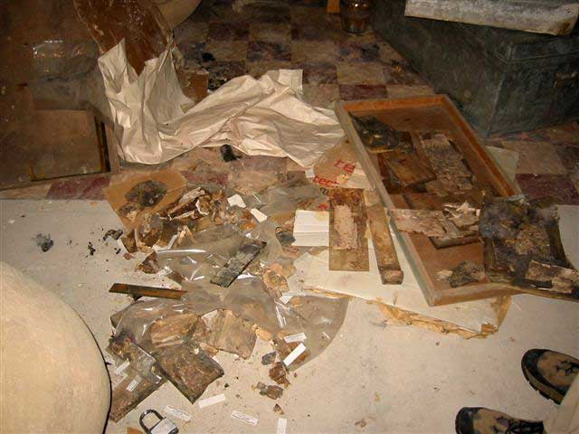

Figure 6. Damaged ivories in store, Iraq Museum, Baghda. © B. Christensen, The British Museum.

Returned objects
Several objects have been returned to the Iraq Museum and they were kept in a separate store room on the ground floor of the Museum. Many of these objects were in good condition; notably ivory pieces from Nimrud and silver jewellery from Assur. Two well known and cherished objects from the Museum were returned damaged; the Warka vase and the statue of Shalmaneser III. Other objects such as small ceramics bowls and one Ubaid rosette (part of the group of six mentioned earlier in this report) were also returned in a damaged condition.

- Warka vase is a one meter high cylindrical limestone vase. It has been restored in the past and in particular the foot and the base of the bowl are heavily restored. The lower portion of the vase below the register of naked ‘priests’ are intact apart from some damage to the restored plaster of Paris foot and bowl. The upper portion of the vase has broken along old break lines into c. ten pieces. The adhesive visible on the break edges would appear to be Shellac (fig. 7). It is our opinion that the Warka vase should be cleaned. Old remnants of adhesive and in-fills should be removed and the vase reassembled using modern conservation materials.

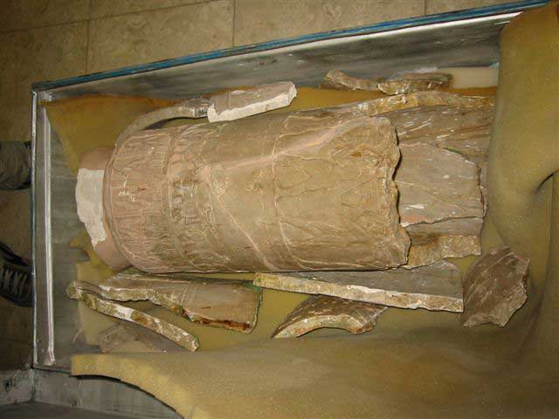

Figure 7. The Warka vase as returned to the Iraq Museum, Baghdad. © B. Christensen, The British Museum.

The statue of Shalmaneser III (stone) has been returned in four pieces; head and three body fragments. It was intact prior to removal from the Iraq Museum. The new breaks are assumed to have occurred along existing lines of weakness in the stone. The left elbow may be missing. The restoration of this statue was started by the Iraqi conservators in preparation for the one-day exhibition of the Nimrud Gold in the Assyrian Gallery. The pieces were carefully drilled and the pieces assembled with iron rods and Paraloid B72; stainless steel is not available in Iraq. Plaster of Paris was used for in-fills and toned in.

External stores
The most precious objects from the Iraq Museum were packed in boxes and stored in secure bank vaults. The objects comprised amongst others the gold, silver and ivory from Nimrud. Many of these objects we were told had been packed since the Gulf war in the 1990s.

At some point in the last six months the vaults were flooded with sewage contaminated water. The water had only recently been pumped out of the bank vaults and drying of objects was in progress as we visited the vaults. The metal objects had been disinfected and dried through purple methylated spirit before being repacked in acid free tissue and cardboard boxes. Some of the objects had also been carefully cleaned for a one day exhibition in the Assyrian Gallery scheduled to open on the 4th July to a selected audience and the press.

The ivories were water saturated. They were as a precaution gently disinfected with purple methylated spirit. The objects were brushed with the solvent and left to air-dry for max. 30 minutes before being repacked in acid free tissue and placed in small card board boxes. These boxes were placed in larger metal boxes. The ivories were still wet when they were packed away. It was recommended that the ivories were dried through a controlled process. The boxes should be regularly inspected and the moisture content checked. The bank vaults were not dry. The floor still had wet patches and there were no desiccators being used to dry the building.

Some of the ivories had been consolidated with PVA which is now blooming. There are cracks in the ivories. Photographs with a ruler to indicate the width and length of the cracks were taken to act as a reference point. The ivories are extremely fragile. Although the drying is controlled the ivories may develop extensive cracking and subsequent require complex conservation treatments. The blooming of the old consolidant will need to be reversed and alternative consolidation should be considered. There is also a risk of mould growth occurring whilst the ivories are packed away.

Frequent monitoring and airing is essential for these ivories to prevent additional damage occurring.

Mosul Museum
There was little damage to objects in Mosul Museum. As in Baghdad it was predominantly stone and ceramic objects that were too big too move prior to the war, which were damaged. Most of Mosul’s smaller objects were taken to Baghdad for safekeeping.

The Balawat Gate’s display had sustained the worst damage. Many fragments have been looted. The bronze encased wooden bar, displayed in the bottom of the glass case has been damaged by falling glass pieces. The metal (bronze) is in a completely mineralised condition (fig. 8), which makes any attempt at restoration complicated.

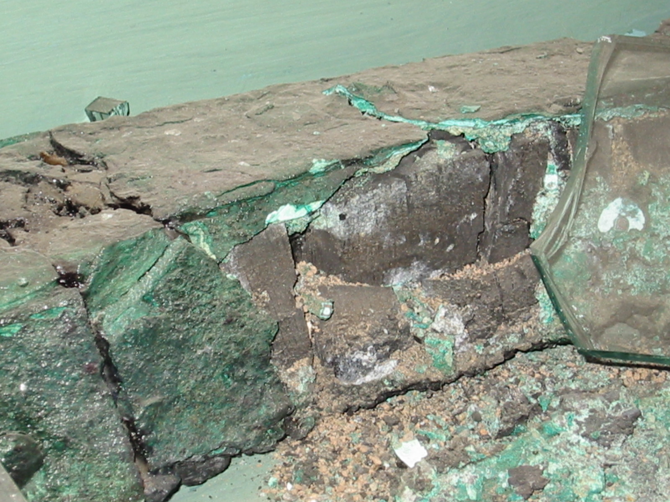

Figure 8. Detail of condition of bronze from the Balawat Gate, Mosul Museum. © B. Christensen, The British Museum.
Babylon
The archaeological site of Babylon was within a military compound and access was problematic. However, the amount of damage to the Museum objects and the standing structures were minimal.

Most of the objects from the Museum were in safe keeping in Baghdad. Large free-standing objects or objects built into the design lay-out had remained in-situ. Fortunately little damage had occurred to the remaining objects in the Museum. However, two important oil on canvas paintings had been partly cut and ripped out of their respective frames and looted.

We detected very little actual recent damage to the building elements. Large cracks are appearing, but the cause and date of these is unknown. The site could benefit from a cross-disciplinary conservation plan taking into consideration elements such as long-term restoration ethics and the use of mortar for repairs, development of reconstructed buildings, visitor management and site access.

Archaeological sites (Nineveh and Nimrud)
Of the two sites Nineveh has sustained more damage than Nimrud. We were informed that an Italian team had carried out a photographic survey at Nineveh six months prior to the outbreak of war. Based on their survey they had proposed a restoration of the stone reliefs and they were due to start 10th April 2003. For obvious reasons they cancelled. It is our recommendation that this team is given the lead on the restoration of the reliefs. Comparing the current state of the reliefs to the photographic survey they should be able to determine the amount of damage attributable to recent events.

We have therefore not considered any help to Nineveh or Nimrud as part of our proposal as other teams are in a much better position than us to take this forward.

Conclusion
Our visit was to establish the conservation help to the Iraq Museum in Baghdad. We have extended this to include the conservator in Mosul and some objects that we consider of high conservation complexity. The conservation help programme is described in a separate document attached to this survey.

We have also identified areas that as far as we know have not been covered by any of the visits to Iraq by archaeologist, historians, conservators and other professionals. We strongly recommend that other conservators with specialists in site management, paper, books and paintings are invited to Iraq to help in their respective areas.

We have commented on the lack of infrastructure in the Iraq Museum, not only in terms of the lack of laboratory facilities and even of basic chemicals for conservation, but also the lack of reliable power and water supplies. While it is planned that new laboratory facilities will be supplied by the Italian Ministry of Cultural Heritage and Antiquities by the beginning of October (see Conservation Plan p.2), the return of the public utilities to normality is less predictable. The continuing instability of the country is a further factor not to be underestimated. In such a context, uncoordinated aid, while well meaning, may be ineffective or at worst of no benefit.

The conservation plan proposed on the basis of the evaluation visit aims to provide Iraqi conservators with the training they themselves wish to have and to coordinate international skills and expertise for the conservation of those types of collections that were found to be most at need. The timing allows for this training and coordination, but also for the installation of laboratory facilities and, it is hoped, the re-establishment of utilities and stability.

Robert Kenneth Uprichard Birthe Kruse Christensen
The British Museum The British Museum

